SECTION {SecNo} — CONTRACT ITEMS AND PRICING
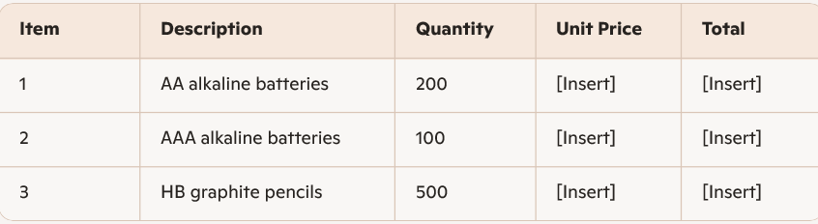
Total Contract Value: Click or tap here to enter text.
Pricing is firm and fixed for the duration of the Contract

